Working with Images in ArcGIS
Assignment created by Constance Holden
Introduction
One of the most common instruments carried on drones is a digital camera. Frequently these cameras are equipped with a GPS (global positioning system) unit, and so the date, time and location at which the image was taken are recorded. To use this image in ArcGIS, we must first georeference it; i.e., give it a coordinate system. The image we will georeference was saved from Google Earth. This process is fairly easy. You locate the area of interest, zooming in and out until you have what you want, then click on the “N” in the compass to be sure that your image is oriented to the north. From the File menu, select Save > Save Image and save it to the desired location. Google Earth images are captured using WGS84 (World Geodetic Survey 1984), so that is the coordinate system we will use for this exercise.

Although we can add images to an ArcMap document, there is no attribute data associated with the image and as a result there can be no analysis of the image in ArcGIS. In order to do an analysis of image data, the image can be “digitized” creating a vector representation of the image, or it can be “classified” creating a raster representation of the image. We can, however, create a raster from an image, and use that raster in an analysis. Our georeferenced image is very large, and digitizing or classifying it would be too time consuming, so a smaller, more detailed image will be used for those purposes.

Procedure:
- Download and extract the data from the Ex_4A folder.
2. Open ArcMap to a blank map.
3. From the Geoprocessing menu select Environments.
a. Click on Workspace to expand it.
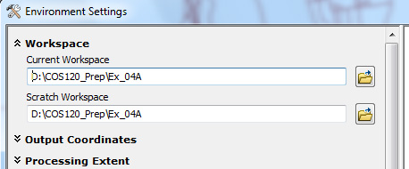
b. Navigate to your Ex_04A folder and click Add to set the directory for your Current Workspace.
c. Repeat for your Scratch Workspace.

PART A: Georeferencing an Image
1. Click on the drop down arrow on the Add Data icon, and add the following data to your project:
a. Orono_Rds
i. Zoom in to the area around the UM campus.
ii. Make the roads a bright color, so they will be visible against an image.
b. Campus.jpg (ignore the warning). You will not be able to see the image, since it has no coordinate system, ArcGIS cannot project it into the same space as the roads.

2. Right-click on Orono Roads and select Properties from the context menu.
a. Click on the label tab.
b. Set the Label Field to STREETNAME.
c. Make the symbol a bright color, size 10 or larger.
d. Click OK.

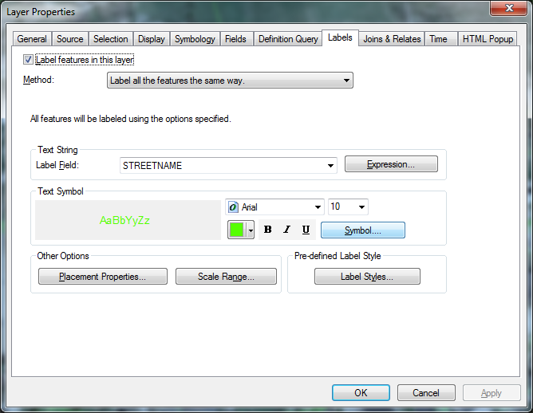

3. Save your project as Ex_04A.

4 From the file menu, select Customize > Toolbars > Georeferencing.
5. Click on the drop down arrow next to “Georeferencing” and select “Fit to Display”.

To georeferenced the image, you will “pull” it into the correct position (aligned with the Orono_Rds file). A good place to start would be Long Road.

6. Locate Long Road on both the image and the Orono_Rds file.
7. Click on the “Add Control Points button. Click on the intersection of Flagstaff Road and Long Road in the image then on the Orono_Rds file (see image below).
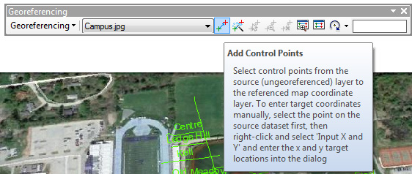

8. Repeat the process with West Mall Road and Sebec Road. This will make the image considerably smaller, so you will need to zoom in again, until you can clearly see road names on both the image and the road file.
9. Continue putting control points around the image until you have added 13 or 14 more points. You want them to be well distributed around the image. Right-clicking will allow you to cancel a point you have started but not completed. You will not be able to get a perfect alignment, as the road file is not perfect, and we are working on a very small area.
10. Open the Link Table.
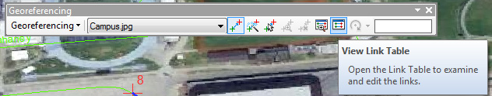

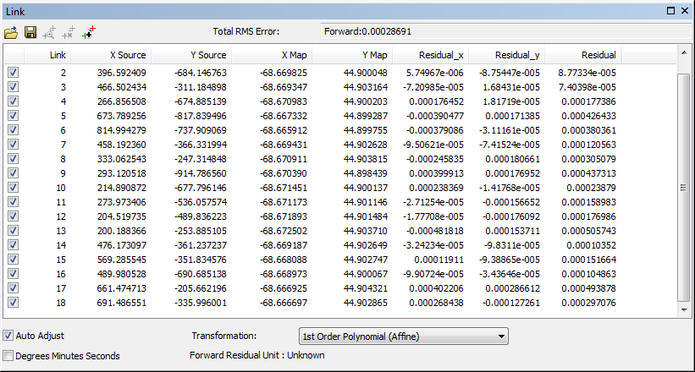

11. We are shooting for a root mean square error (RMS Error) of lee than 5. If your RMS Error is greater than 5, look at the Residual’s column. Delete the point with the largest residual by selecting it and clicking on the delete button.
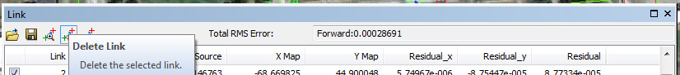

12. Keep removing large links until you have and RMS less than 5. If you have fewer than 10 remaining links, go back to the image and add more. Your goal is to end up with at least 10 points, an RMS Error less than 5 and a reasonable alignment between the roads and the image.
13. When you have achieved your goal, click on the drop down arrow next to georeferenced and select Rectify. Save the image in your Ex_04A folder with the name Campus_R.tif. This will save your georeferenced image with its new coordinate system.
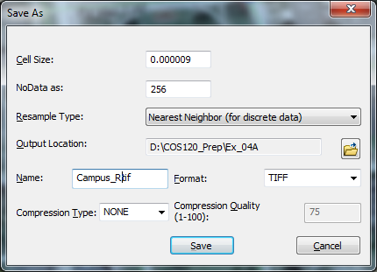

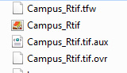
14. Minimize ArcGIS and navigate to your Ex_04A folder. You should see four new files:

15. Use Notepad, WorPad or some other ASCII-based word processing program to open Campus_Rtif.tfw. This is the world file. It contains 6 lines. The first line is the oixel size in the x-direction, while the fourth is the pixel size in the y-direction. Lines two and three describe any rotation of the image and the last two lines giving the coordinates for the center of the upper left pixel.

PART B: Digitizing an Image
- Open ArcCatalog and navigate yo your Ex_04A folder.
- Right-Click anywhere within the folders and select New > Shapefile.
  - Call it Perch_Pond and make a polygon shapefile.
  - Click on Edit and select a Geographic Coordinate System > World >WGS84.
  - Click OK to close the dialog box.

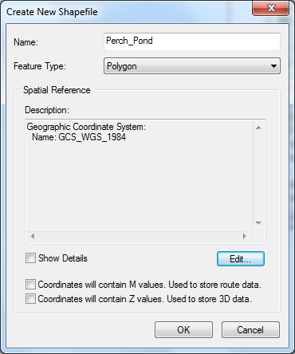

- Close ArcCatalog.
- Maximize ArcGIS.
- On the menu bar, select Insert > New Data Frame.
- Add the following data to the data frame:
  - Perch_Pong.jpg, and center the image on the screen.
  - Perch_Pond.shp. It will appear in the Table of Contents, but nothing will show in the data frame, as we have not yet created it.
- Click on the Editor Toolbar icon, to bring up the Editor Toolbar.
  - From the Editor drop down menu choose Start Editing.
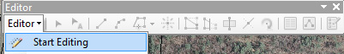

  - A Create Feature Panel appears on the screen.
  - Click on Perch_Pond, to bring up the Construction Tools.
  - Choose “Polygon”.
  - Start in the upper right-hand corner, and left-click to create shape-point all around the boundary of the pond. When you get to the upper left-hand corner right-click and select Finish Sketch.
  - Click on the Editor drop down arrow and select “Save Edits” then “Stop Editing”.

- Right-Click on the Perch_Pond shapefile in the TOC and select “Open Attribute Table”. Click on the Table Options drop down box and select “Add Field”
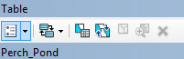

Add the following fields”
- Name – Type: Text, Length: 25 – Click OK when done
- AltName - Type: Text, Length: 25– Click OK when done
- Location - Type: Text, Length: 25– Click OK when done
- Acreage – Type: Short Integer, Precision 0– Click OK when done
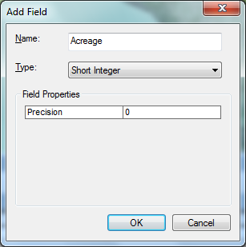
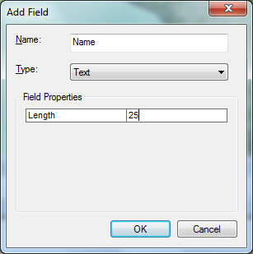
- MaxDepth - Type: Short Integer, Precision 0– Click OK when done

- Start Editing and fill in the table with the following information:
  - ID: 2278
  - Name: Perch Pond
  - AltName: Mud Pond
  - Location: Old Town, ME
  - Acreage: 366
  - MaxDepth: 12
- Save your edits and stop editing. You have now created a shapefile with accompanying data.

PART C: Classifying an Image
In this part of the lab, you are going to do what is called a supervised classification of the image. You are going to create training samples for: water, roads, barren area, shrubs (lighter green) and forest (darker green). The computer (the image classification tool) will search for all of the pixels similar to the ones you have selected and will classify the entire image.
- Insert a new data frame and add your Perch Pond Image.
- From the Customize menu, select Toolbars > Image Classification.
- Select your “drawing” tool, the circle or rectangle are the easiest.
Training Sample Manager

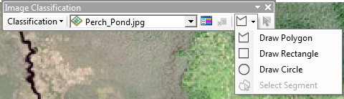

- Open the Training Sample Manager.
- With your drawing tool, take several samples of water in areas without clouds, and change the color in the Training Sample Manager to a dark blue, by clicking on the color patch and selecting a new color. You can also edit the class names.
- Repeat the process on the barren area. Since it is not uniform in color you might want to assign variations in a color.
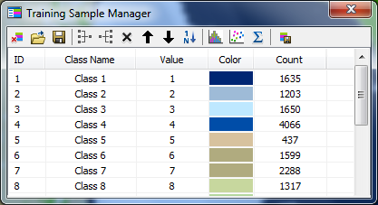

- Continue with the shrubs and forest.
- When you think you have what you want, click on the Classification drop down arrow and select, “Interactive Supervised Classification”.
- If you are not satisfied with your results, you can change them.
  - Use the identify tool, and click on an area you believe is incorrectly classified, to see how it was classified.
  - Click on the color patch in the TOC and change it.
- Right-click on your raster in the TOC and examine the attribute table. The table has cell values that cell values that represent or define a class, group, category, or membership, to which you can add additional fields.

